PROJECT REPORT
ON
Big Data Analytics in Healthcare Analytics

Subject Name: Big Data Analytics
Subject Code: BDA601
Submitted By: Submitted To:
Deepu S Ms. Surbhi
1AY23CD026

Table of Contents:

Topic | Page No:
1.About the Project | 3-5
2.About the Tools and Technologies  Used | 6-7
3.Detailed Description of My  Contribution  3.1 What is Done and How it is Done  3.2 Code Explanation | 8-9
4.Implementation Code | 10-13
5.Results | 14-16
6.Conclusion | 17-17
Figures:  1.1: Transformed Data  1.2: Dashboard | 15-16

Task 1: - Big Data in Daily Life – Visual Storytelling 17-18

Task 2: BI vs Big Data – Role Play 18-20
Task 3: Architecture Design Challenge 20-21
Task 4: Analytics & Tool Match 22-23
Bonus Challenge 24

- ABOUT THE PROJECT:

1.1 Overview of Healthcare Data Analytics
Today’s healthcare organizations produce a massive amount of digital data every single day. Each patient visit generates various types of information, including:
- Patient personal and demographic information
- Laboratory test results
- Medication and prescription records
- ICU and vital sign monitoring data
- Billing and financial records
- Appointment scheduling data
- Insurance documentation
- Diagnostic imaging files (MRI, CT, X-ray)
In large healthcare facilities:
- Thousands of patients receive care daily
- Millions of medical records are stored digitally
- Monitoring devices continuously stream patient health data
- Imaging technologies generate large data files per scan
Conventional data systems often fail to efficiently manage, store, and analyze this rapidly growing healthcare information.
This creates the need for advanced Healthcare Analytics using Big Data technologies.

1.2 The 5V Characteristics of Big Data in Healthcare
Healthcare data reflects the five major properties of Big Data:
Volume:
Healthcare institutions maintain huge datasets such as:
- Electronic Medical Records (EMR/EHR)
- Radiology and diagnostic images
- Intensive care monitoring records
- Pharmacy and inventory databases
- Insurance and financial data
Large hospitals may generate terabytes of information each month.

Velocity:
Healthcare data flows at a very high speed:
- Continuous patient vital monitoring
- Real-time emergency room updates
- Instant lab report generation
- Live wearable device tracking
Quick access to this data is crucial for timely medical decisions.

Variety:
Healthcare information comes in multiple formats:
- Structured data – Numerical lab results, patient age, blood pressure
- Semi-structured data – Digital prescriptions, insurance claim files
- Unstructured data – Clinical notes, discharge summaries, medical images
Effective healthcare analytics must handle all these diverse data forms.

Veracity:
Medical datasets may include:
- Incomplete patient records
- Incorrect data entries
- Duplicate patient IDs
- Inconsistent clinical information
Maintaining high data accuracy and reliability is essential for correct analysis.

Value:
Analysing healthcare data can help organizations:
- Decrease patient waiting times
- Forecast disease trends
- Improve staff and resource planning
- Enhance treatment effectiveness
- Reduce healthcare costs
Healthcare analytics converts raw medical information into useful insights that support better decision-making.

1.3 Why Traditional BI Fails in Healthcare
Traditional Business Intelligence tools such as spreadsheets and basic database systems have significant drawbacks in healthcare environments:
- Inability to manage large imaging datasets efficiently
- Lack of real-time data processing capabilities
- Limited scalability for expanding healthcare systems
- Performance issues with large patient databases
- Minimal support for predictive analytics and AI applications
Modern healthcare requires:
- Real-time data processing
- Distributed and cloud-based storage
- Predictive and machine learning models
- Scalable data infrastructure
- Intelligent decision-support systems
Therefore, Big Data solutions are essential for modern Healthcare Analytics to ensure efficient operations and improved patient outcomes.

2. ABOUT TOOLS & TECHNOLOGIES (DETAILED)

2.1 Microsoft Power BI

Purpose: Data visualization and reporting

Use in Healthcare:

Creating hospital performance dashboards

Tracking patient admissions and discharge rates

Monitoring ICU occupancy

Analyzing billing and revenue data

Visualizing disease trends

Benefit: Helps management make data-driven decisions using interactive reports.

2.2. Apache Hadoop

Purpose: Distributed data storage

Use in Healthcare:

Storing Electronic Health Records (EHR)

Managing large medical imaging files

Handling historical patient data

Benefit: Scalable storage for massive healthcare datasets.

2.3. Apache Spark

Purpose: Fast data processing and analytics

Use in Healthcare:

Real-time ICU data analysis

Disease prediction models

Processing large healthcare datasets

Benefit: High-speed computation for real-time analytics.

2.4. Python

Purpose: Data analysis and machine learning

Use in Healthcare:

Disease risk prediction

Patient readmission analysis

EEG signal processing

Medical data analysis

Benefit: Supports AI and machine learning applications in healthcare.

5. NoSQL Databases (MongoDB)

MongoDB

Purpose: Flexible database management

Use in Healthcare:

Storing semi-structured medical data

Managing insurance claims

Handling real-time patient monitoring data

Benefit: Handles large and varied healthcare data efficiently.

3. DETAILED DESCRIPTION OF CONTRIBUTION

3.1 What is Done and How it is Done

3.1.1 Data Understanding
For this Healthcare Analytics project, the dataset utilized is a Healthcare Patient Records Dataset obtained from Kaggle. The dataset consists of hospital visit and treatment records used to evaluate clinical performance, patient behavior, and hospital efficiency.
Each record in the dataset corresponds to one patient visit or treatment event. The dataset includes the following fields:
- Patient_id
- admission_date
- discharge_date
- doctor_id
- treatment_cost
- admission_type (Emergency / Regular)
- readmission_status
The readmission_status column categorizes patients into:
- Readmitted
- Not Readmitted
- (Other categories if available)
This dataset supports analysis of:
- Patient admission trends
- Department-wise performance
- Doctor utilization rates
- Treatment cost distribution
- Readmission patterns
- Hospital resource usage
Understanding the dataset structure helped in identifying key healthcare performance indicators and planning the analytical approach.

3.1.2 Data Preprocessing
Data cleaning and preparation were performed using:
Microsoft Power BI
The following preprocessing procedures were applied:
- Imported the dataset using Home → Get Data → Text/CSV → Load
- Reviewed the dataset in Power Query Editor
- Ensured correct data types (Date, Text, Numeric, Currency)
- Converted admission_date and discharge_date into proper Date format
- Created a calculated column for Length of Stay (Discharge Date – Admission Date)
- Checked and handled missing or null values
- Standardized categorical values (e.g., Emergency vs emergency)
- Removed duplicate patient entries (if found)
- Extracted Month and Year from admission_date
- Created Month Number column to maintain chronological sorting
These preprocessing steps improved data consistency and ensured accurate dashboard calculations.

3.1.3 Analytical Logic Applied

The analytical framework of the healthcare dashboard focuses on key hospital performance metrics.
The core analysis includes:
- Calculating total patient admissions
- Measuring total treatment revenue
- Counting unique patients
- Identifying total active doctors
- Computing average length of hospital stay
- Determining readmission rate
- Analyzing department-wise patient distribution
- Tracking monthly admission trends

4. IMPLEMENTATION OF CODE

4.1 Overview of Implementation
The implementation stage of the Healthcare Analytics project included the following steps:
- Importing the healthcare patient dataset into Microsoft Power BI
- Performing data transformation and validation using Power Query
- Creating calculated columns and DAX measures for clinical analysis
- Designing interactive dashboard reports for hospital performance monitoring
The primary table used in the data model is:
Healthcare_records
Each row in the table represents a single patient admission or treatment record.

4.2 DAX Measures Implementation:
Several DAX measures were created to support analytics.
4.2.1 Total Admissions
Total Admissions = COUNT(healthcare_records[patient_id])
Explanation:
- Counts total patient admission records.
- Represents overall hospital admission volume.
- Useful for measuring hospital activity levels.

4.2.2 Unique Patients:
Unique Patients = DISTINCTCOUNT(healthcare_records[patient_id])
Explanation:
- Counts distinct patient IDs.
- Prevents duplicate counting of patients with multiple visits.
- Helps measure actual patient reach.

4.2.3 Total Revenue:
Total Revenue = SUM(healthcare_records[treatment_cost])
Explanation:
- Calculates total income generated from treatments.
- Supports financial performance analysis.
- Helps management evaluate revenue growth.

4.2.4 Average Length of Stay:
Average Length of Stay = AVERAGE(healthcare_records[length_of_stay])
Explanation:
- Computes the average hospitalization duration.
- Helps assess bed occupancy efficiency.
- Indicates treatment effectiveness and discharge efficiency.

4.2.5 Readmission Rate:
ReadmissionCount=
CALCULATE(
COUNT(healthcare_records[patient_id]),
healthcare_records[readmission_status]="Readmitted"
)
Explanation:
- Uses CALCULATE() to apply a filter condition.
- Counts only patients marked as "Readmitted".
- Helps identify quality-of-care issues.

4.2.6 Emergency Admission Percentage:
EmergencyAdmissions =
CALCULATE(
COUNT(healthcare_records[patient_id]),
healthcare_records[admission_type]="Emergency"
)
Explanation:
- Filters admission_type column.
- Measures hospital emergency case load.
- Helps plan emergency staff allocation.

4.2.7 Month Extraction Column:
Month Number = MONTH(healthcare_records[admission_date])
Explanation:
- Extracts month value from admission date.
- Maintains chronological order for trend analysis.
- Supports time-based reporting.

4.3 Dashboard Implementation Logic
The calculated measures were integrated into different Power BI visuals
KPI Cards

Displayed:

Total Admissions

Unique Patients

Total Revenue

Readmission Count

Average Length of Stay

These KPIs provide a quick summary of hospital performance.

Line Chart – Monthly Admission Trend

Axis→Month
Values → Total Admissions

This visual highlights seasonal trends and peak admission periods.

Bar Chart – Department Performance

Axis→Department
Values → Total Admissions

This chart identifies departments with the highest patient load.

Column Chart – Revenue by Department

Axis→Department
Values → Total Revenue

Used to evaluate department-wise financial contribution.

Pie Chart – Admission Type Distribution

Legend→admission_type
Values → Total Admissions

Displays proportion of emergency vs regular admissions.

Slicers Implemented

Month

Department

Admission Type

Slicers allow users to dynamically filter the dashboard and perform interactive analysis

5. RESULTS ANALYSIS

5.1 Healthcare Performance Overview
The KPI dashboard section presents a consolidated summary of key hospital indicators, including:
- Total patient admissions
- Number of unique patients
- Total revenue generated
- Average length of hospital stay
- Readmission count
These performance indicators provide hospital administrators with a quick snapshot of overall healthcare operations. By reviewing these metrics, management can evaluate service demand, financial performance, and patient care efficiency in a single view.

5.2 Admission Trend Analysis
The monthly admissions line chart reveals:
- Periods with high patient inflow
- Months with reduced hospital activity
- Seasonal or cyclical admission patterns
This analysis supports hospital planning by identifying peak demand periods. Management can use this information to allocate beds, schedule staff shifts, and prepare resources accordingly. Trend monitoring also helps predict future admission volumes.

5.3 Department and Resource Utilization Analysis
The department-wise bar chart illustrates:
- Departments treating the highest number of patients
- Units with comparatively lower patient load
- Distribution of healthcare service demand
This analysis helps in identifying resource imbalances across departments. If certain departments experience excessive patient volume, hospital management can redistribute staff or increase infrastructure support to ensure efficient service delivery.

5.4 Readmission and Admission Type Insights
The pie or donut chart displays the distribution of:
- Readmitted vs Non-readmitted patients
- Emergency vs Regular admissions
A higher readmission rate may suggest:
- Gaps in treatment effectiveness
- Inadequate discharge planning
- Post-treatment complications
Similarly, a high percentage of emergency admissions may indicate:
- Increased acute care demand
- Seasonal health risks
- Public health concerns
Tracking these indicators enables hospitals to improve patient care strategies and optimize operational efficiency.

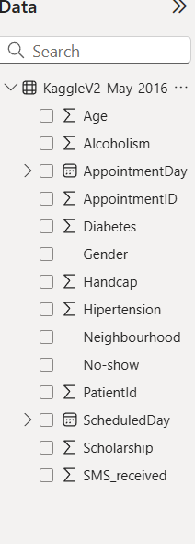
Figure 1.1: Transformed appointments data used for visualization and DAX measures.

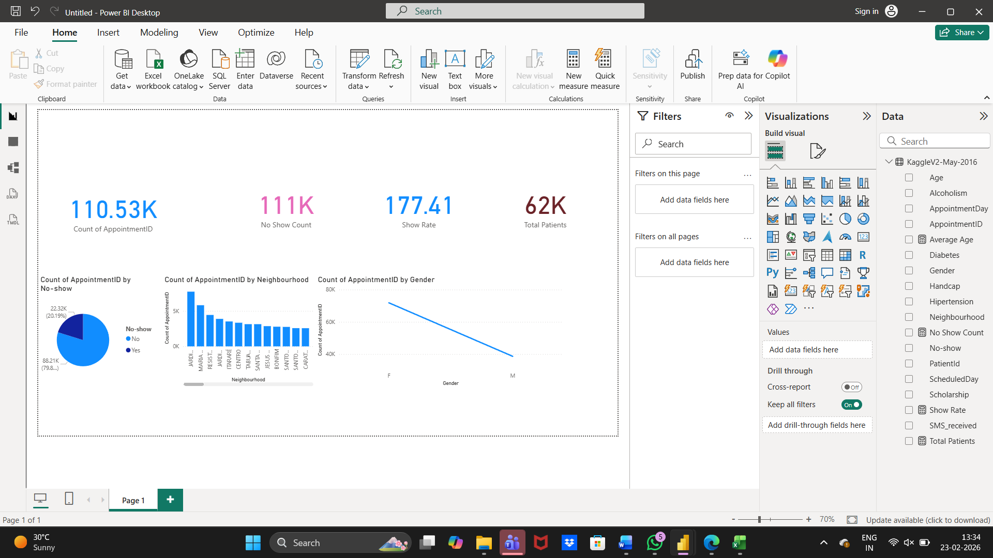

Figure 1.2: Interactive Hospital Management Dashboard created using Power BI.

Dataset Used :

https://www.kaggle.com/datasets/joniarroba/noshowappointments

6. CONCLUSION:

This project demonstrates how Big Data analytics can improve hospital management systems. By transforming large-scale healthcare data into meaningful dashboards, hospitals can improve operational efficiency, reduce costs, and enhance patient care quality.
The integration of distributed storage, real-time processing, and interactive visualization enables data-driven medical decision-making.

Task 1: Big Data in Daily Life – Visual Storytelling: Healthcare Analytics

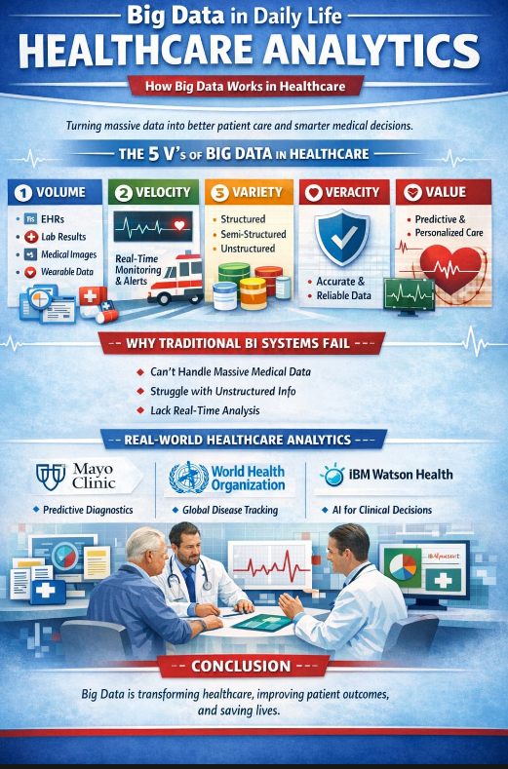
Fig 1.3: Visual Storytelling: HealthCare Analytics
Imagine visiting a hospital where your medical history, lab reports, prescriptions, and even smartwatch data are instantly available to your doctor. This seamless experience is powered by Big Data in Healthcare Analytics.
Healthcare data is classified into three types. Structured data includes organized records like patient details, billing information, and lab results. Semi-structured data includes wearable sensor logs and e-prescriptions. Unstructured data consists of doctor’s notes, medical images (MRIs, CT scans), and audio records.
This system works through the 5 Vs of Big Data: Volume (massive medical records), Velocity (real-time monitoring), Variety (different data formats), Veracity (accuracy and reliability), and Value (better diagnosis and treatment).
Traditional BI systems fail because they cannot process large imaging files, unstructured notes, or real-time data efficiently. Big Data is required to analyze complex health patterns, predict risks early, personalize treatments, and transform healthcare from reactive care to proactive, life-saving decision-making.

TASK 2: BI vs Big Data – Role Play

Scenario: A discussion between a Data Consultant and a Manager who believes Excel and SQL are sufficient for business needs.
Manager: I don’t understand why everyone is talking about Big Data. We already use Excel and SQL for reports. Isn’t that enough?
Data Consultant: Excel and SQL are powerful tools, but they work best with structured and limited data. Today, businesses generate massive amounts of data every second — website clicks, mobile app usage, customer reviews, social media posts, and IoT sensor data.
Manager: But we store our data in relational databases and generate reports using BI tools. That works fine.
Data Consultant: Traditional Business Intelligence (BI) systems are mainly designed for structured data stored in tables. They focus on historical analysis — such as last month’s sales or quarterly performance. They struggle with very large, fast, and unstructured data.
Manager: What are the limitations of traditional BI?
Data Consultant: There are several limitations:
- Limited scalability (mostly vertical scaling)
- Handles mainly structured data
- Slower processing with very large datasets
- Focuses on descriptive analytics (what happened)
- Not suitable for real-time analytics
Manager: So, when did this shift toward Big Data happen?
Data Consultant: The shift began when companies like Google and Facebook started handling petabytes of data daily. Traditional systems could not process such massive volumes efficiently.
Manager: So, what was the solution?
Data Consultant: Distributed computing. Technologies like Apache Hadoop were introduced. Hadoop allows data to be stored across multiple machines and processed in parallel, which improves scalability and performance.
Manager: Why not just upgrade to a more powerful server?
Data Consultant: That approach is called vertical scaling — it is expensive and has hardware limits. Hadoop uses horizontal scaling, where we add more affordable machines to the cluster, making it cost-effective and scalable.
Manager: What about databases? Do we still use SQL?
Data Consultant: Yes, SQL is still important. However, Big Data introduced NoSQL databases like MongoDB and Cassandra. These databases handle flexible schemas, large volumes of data, and high-speed processing better than traditional relational databases.
Manager: So, NoSQL replaces SQL?
Data Consultant: Not completely. SQL is ideal for structured transactional systems. NoSQL is better for high-volume, high-velocity, and unstructured data. They complement each other.
Manager: What are the real business benefits of Big Data?
Data Consultant: Big Data provides:
- Real-time fraud detection
- Personalized product recommendations
- Predictive analytics and forecasting
- Customer sentiment analysis
- Operational optimization
- Better decision-making through data-driven insights
Manager: Can you give a practical example?
Data Consultant: For example, in retail, Big Data systems analyze customer purchase behaviour and social media trends in real time. This helps businesses adjust pricing, manage inventory, and launch targeted marketing campaigns instantly.
Manager: So BI tells us what happened, and Big Data tells us what will happen?
Data Consultant: Exactly. Traditional BI focuses on descriptive analytics, while Big Data enables predictive and prescriptive analytics. It helps businesses stay competitive in a data-driven world.
Manager: Now I understand. Excel and SQL are useful, but Big Data technologies are necessary for modern business growth.
Data Consultant: Absolutely. Big Data is not replacing BI — it is extending its capabilities to handle modern data challenges.

TASK 3: Architecture Design Challenge

The architectural design for Healthcare Analytics, comparing the legacy approach to the modern Big Data powerhouse.

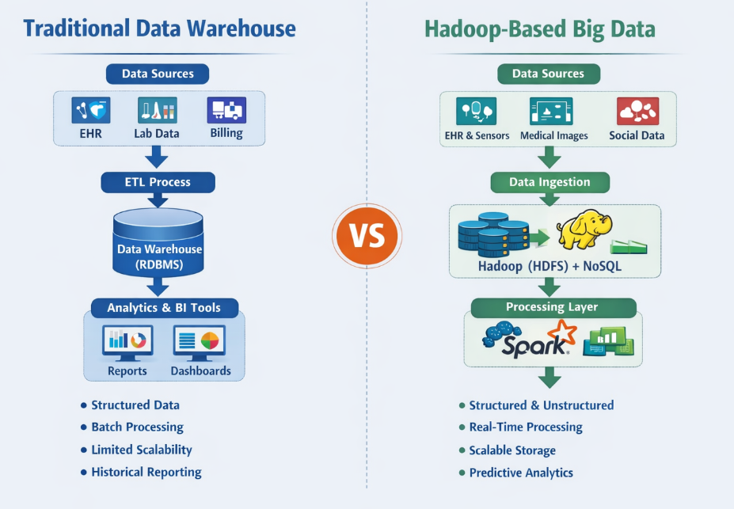

Fig 1.3 Traditional Data Warehouse Vs Hadoop-based Big Data Traditional Data Warehouse Architecture
Data Sources
- Electronic Health Records (EHR)
- Laboratory and Pharmacy Systems
Storage Layer
- Centralized Relational Database (RDBMS like Oracle/MySQL)
- Structured tables (rows and columns)
- Predefined schema (Star/Snowflake schema)
Processing Layer
- ETL (Extract, Transform, Load) process
- Data cleaning and transformation before loading
- Batch processing (daily/weekly updates)
Analytics Layer
- BI dashboards and static reports
- Patient admission statistics
- Revenue and department performance reports
- Historical trend analysis (Descriptive analytics – “What happened?”)

Hadoop-Based Big Data Architecture
Data Sources
- EHR systems
- Wearable devices (heart rate, glucose monitors)
- Medical imaging (MRI, CT scans)
- Clinical notes and public health data
Storage Layer
- Apache Hadoop (HDFS – distributed storage)
- NoSQL databases like Cassandra
- Data Lake storing structured + unstructured data
Processing Layer
- Parallel processing using MapReduce
- Fast processing with Apache Spark
- Machine Learning models for disease prediction
Analytics Layer
- Real-time patient monitoring dashboards
- Predictive analytics (early disease detection)
- Clinical decision support systems
- Fraud detection and population health analysis

TASK 4: Analytics & Tool Match (Hospital Version)

Business Question | Healthcare Example | Analytics Type | Tools Used
What happened? | How many patients were admitted last month? What was the mortality rate? | Descriptive Analytics | BI Tools, SQL, Data Warehouse
Why did it happen? | Why did ICU admissions increase? Why did infection rates rise? | Diagnostic Analytics | SQL Queries, Data Mining, Apache Spark
What will happen next? | Which patients are at risk of readmission? Will flu cases increase? | Predictive Analytics | Machine Learning Models, Apache Hadoop, Spark
What action should be taken? | Which treatment plan should be recommended? How should ICU beds be allocated? | Prescriptive Analytics | AI Models, Optimization Algorithms, Spark, NoSQL

BONUS CHALLENGE

Explain Big Data in Hospital to a 10-year-old

Big Data is like having a super huge collection of information. Imagine every time you watch a video, play an online game, use a mobile app, visit a hospital, or wear a smartwatch, information is created. Now imagine millions of people around the world doing this every second. That creates a very, very large amount of information. This is called Big Data.
Big Data is not just big in size. It also comes in different forms. It can be numbers (like marks in school), words (like messages or doctor notes), pictures, videos, and even heart rate data from fitness bands. All this information keeps growing very fast.
Normal computers can handle small amounts of data, but they struggle with Big Data because it is too large and complex. So special systems are used. For example, Apache Hadoop helps many computers work together as a team to store and process huge amounts of information quickly.
Big Data is important because it helps people make better decisions. Doctors can use it to predict diseases early. Hospitals can monitor patients in real time. Schools can understand how students are learning. Companies can suggest products or videos that you might like.
In simple words, Big Data means a very large amount of information that grows quickly and helps people find useful answers. It turns lots of information into smart ideas that make life easier and better.

